**TEXT CLASSIFICATION INTO EMOTIONAL STATES USING DEEP LEARNING BASED BERT TECHNIQUE**

**ABSTRACT**

The classification of emotional states from poetry or formal text has received less attention by the experts of computational intelligence in recent times as compared to informal textual content like SMS, email, chat, and online user reviews. In this study, an emotional state classification system for text is proposed using the latest and cutting edge technology of Artificial Intelligence, called Deep Learning. For this purpose, a BERT model is implemented on the text corpus. The proposed approach classifies the text into different emotional states, like neutral, joy, fear, sadness, anger, etc.

**Keywords:** Deep learning, emotion recognition, text, BERT, formal text, emotional states

**EXISTING METHOD**

In existing system, emotions from the text are detected manually by humans by analysing the content present in the text. This technique consumes tons of time for analysing the content.

**Disadvantages:**

• Low accuracy.

• Time consuming.

• High complexities.

**PROPOSED METHOD**

In our proposed model, we have created a system that which classifies the emotional states of the text by using the deep learning based BERT. The proposed approach classifies the text into different emotional states, like neutral, joy, fear, sadness, anger, etc. The block diagram of the proposed is shown in below diagram.

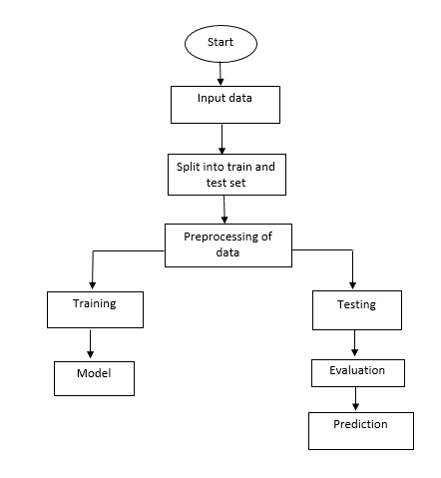

**Fig 1. Block diagram of proposed method**

**Advantages:**

* High accuracy.
* Time Saving.
* Low complexities.
* High reliability.

**APPLICATIONS**

* Genre classification, automatically determining the genre of a text
* Emotion classification from text

**SYSTEM SPECIFICATIONS**

**HARDWARE & SOFTWARE REQUIREMENTS**

# **H/W Configuration:**

# Processor : I3/Intel Processor

* Hard Disk : 160GB
* RAM : 8Gb

**S/W Configuration:**

* Operating System : Windows 7/8/10 .
* IDE : Google Colab.
* Libraries Used : Numpy, Pandas, nltk, IO, OS.
* Technology : Python 3.6+.

**ARCHITECTURE**

